Superpixel Merging Software User Guild

Zhongwen Hu

[zwhoo@szu.edu.cn](mailto:zwhoo@szu.edu.cn)

Shenzhen University

Website: <http://spatial.szu.edu.cn/user_details?id=15&type=教师>

Blog: <http://blog.csdn.net/Guzenyel/article/category/2263691>

QQ群：217312431

Introduction

This software is designed to perform superpixel merging. It is developed using Microsoft visual studio C++. This is an academic software, and commercial use is prohibited.

There are 7 parameters:

|  |  |  |
| --- | --- | --- |
| index | Parameters | description |
| 1 | The path of source image file. |  |
| 2 | The path of superpixel file. | An int32 image file. The value of each pixel denotes the superpixel label of this pixel. This file can be obtained using a superpixel segmentation algorithm, such as SLIC, watershed, SCoW, Seeds, etc. |
| 3 | The path of result file. | An int32 image file that storages the final merged superpixel labels. You need to visualize the superpixels in other software. |
| 4 | The merging criterion  (0-3) | Four merging criteria are provided:  ***(1) Baatz &Schape：***          ***Reference:*** *M. Baatz and A. SchApe, “Multiresolution segmentation: an optimization approach for high quality multi-scale image segmentation,”*Angewandte Geographische Informationsverarbeitung XII*, pp. 12–23, 2000.*  ***(2) Full Lambda:***    *N is the area, u is the mean spectral value, l is the shared boundary of region i and j, λ is the shape parameter.*  ***Reference:***  ***(3) Spectral Histogram:***    *G(i,j) is the G-Statistic value of two spectral histograms i and j.*  *Reference: A. Wang, S. Wang, and A. Lucieer, “Segmentation of multispectral high resolution satellite imagery based on integrated feature distribution,” Int.J. Remote Sens., vol. 31, no. 6, pp. 1471–1483, Feb. 2010.*  ***(4) Color-Texture Model:***    *Gc is the G-Statistic value of two spectral histograms, Gt is the G-Statistic value of two LBP texture histograms; wc and wt are the corresponding weights, they are automatically estimated.*  ***Reference:***  *(1)* [*A Spatially-Constrained Color-Texture Model for Hierarchial VHR Image Segmentation. IEEE Geoscience and Remote Sensing Letters. 2013, 10(1), 120-124.*](http://spatial.szu.edu.cn/findings_details?type=0&id=25)  (2) [结合光谱纹理与形状结构信息的遥感影像分割方法. 测绘学报](http://spatial.szu.edu.cn/findings_details?type=0&id=35), [2013, 42(1), 44-50.](http://spatial.szu.edu.cn/findings_details?type=0&id=35)  (3) 基于区域的影像多尺度表达与应用研究，胡忠文，武汉大学博士论文，2013. |
| 5 | The number of regions after region merging. | An integer value. For example, 30 means there are about 30 regions after the region merging. |
| 6 | The shape parameter (0-1) | A float value. If the Baatz&Schape criterion is used, the parameters corresponds to wshape.  If the other three merging criteria are used, the parameter corresponds to λ. |
| 7 | The compact parameter (0-1) | A float value. This parameter is only used in Baatz & Schape merging criterion. |

Other reference:

***RAG-NNG:***

Hybrid image segmentation using watersheds and fast region merging,” *IEEE Trans. Image Process, 1998*

***Hierarchical Region Merging:***

Hierarchy in picture segmentation: A stepwise optimization approach,” *IEEE Trans. Pattern Anal. Mach. Intell.*, 1989

**A Demo is provided. The usage is provided in Demo.bat. You can edit it for your work.**

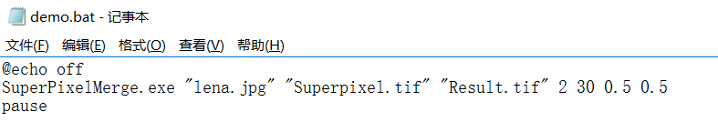

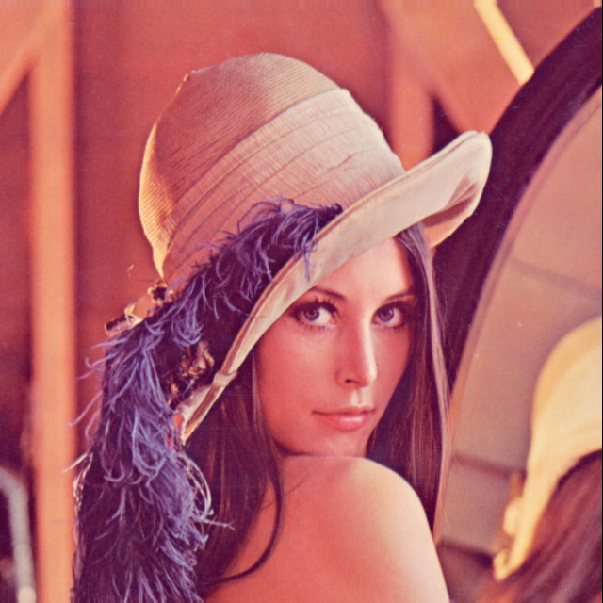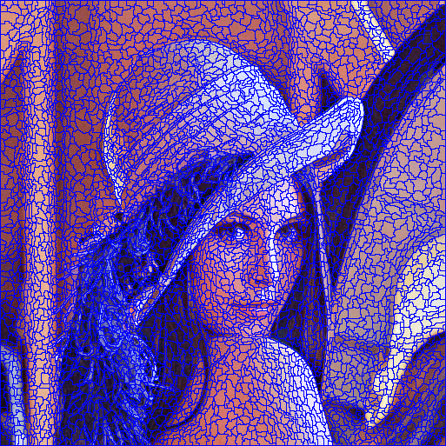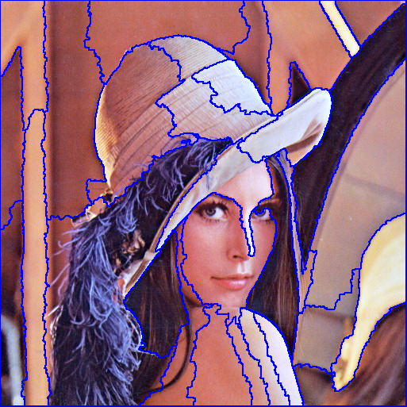

Source image, superpixels, final results.

*My other related works*

(1) Watershed Superpixel. ***IEEE ICIP*** 2015.

(2) A Bi-level Scale-sets Model for Hierarchical Representation of Large Remote Sensing Images, ***IEEE TGRS***, 2016.

(3) Unsupervised Simplification of Image Hierarchies via Evolution Analysis in Scale-Sets Framework, ***IEEE TIP***,2017.

*Sponsor:*

 

<http://spatial.szu.edu.cn/> <http://www.viswtech.com/>